Meta Title: Fall of the Roman Empire: 3 Major Reasons for It
Meta Description:
The Roman Empire was arguably the most important and powerful empire in history but why did it fall? Here are the four major reasons for the fall of the Roman Empire.
Meta Tags:
Fall of the Roman Empire

3 Major Reasons Behind the Fall of the Roman Empire
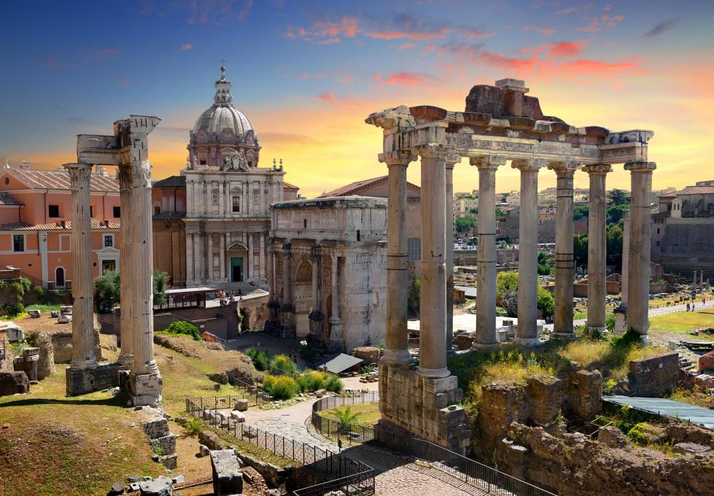
Image Text: Temples and ruins of Ancient Rome
Alt-Text: Temple and ruins that were once part of the fallen Roman Empire
Description: Temples and ruins that were part of the Roman Empire

The fall of the Roman Empire can be likened to stepping on one’s own toes or dropping a hammer on your own foot. This is because the Romans were their own worst enemies. The greatest examples of this are the Terrible Trios of the Roman Empire—Caesar, Pompey, and Crassus. The Roman Empire was one of the mightiest and most powerful empires the world has ever seen. It ruled over Europe for almost a thousand years. During this time, the culture of Rome was widespread and evident in each and every corner of Europe.
Even today, you will find the influence of the Roman Empire and culture in architecture, literature, and language.

The History of the Roman Empire: How It All Started
The Roman Empire started with the Roman Republic. The Republic was not ruled by a king. Instead, elected Senators governed it. Even in those days, Rome had an appointed government, a constitution, written laws, and a balance of power.
The Roman Republic ruled over Rome for hundreds of years until Julius Caesar took over in 45 B.C and established himself as the supreme ruler. Caesar took control over Rome because he wasn’t happy with how things were being run, much like how parents take over when their kids become too rowdy or destructive. Caesar gave incredible speeches in which he informed commoners how the senators were cheating and looting them. This made the people of Rome like him a lot. However, Caesar became popular because of the duals he organised between wild animals and gladiators which often ended in a bloody, violent outcome.
The violent shows were funded by Caesar’s rich friend and one of the Terrible Trios Crassus. Crassus was extremely rich, but this wasn’t enough to make him happy. He joined hands with his pals Caesar and the merciless Roman general Pompey to seize power. The Terrible Trio were successful in their plot and seized control over Rome to wreak havoc.

Roman Britain: The Roman Conquest of Britain
Julius Caesar decided to invade Britain in 54-55 B.C to teach a lesson to the Britons who had been helping Gaul i.e. present-day France to fight the Romans. Since the intention of Caesar was not to rule over Britain, he quickly made truce with his opponents in the British lands he had invaded. He soon returned to Gaul, leaving Britain to its rightful owners.
Britain lived in peace for another 90 years, much like parents who have their kids spend the weekend at their grandparents’ place. However, just like how that peace is disturbed when kids return home, Britain’s peace was disturbed when the Romans, led by the emperor Claudius, decided to return to English lands in 43 A.D.
Unlike Caesar’s conquest of Britain, this time it was a full-scale invasion, intended for military glory and change of regime. For almost 17 years following the invasion, the Romans enjoyed rapid military success. However, their march towards glory was halted by a rebellion led by Boudicca, the queen of East Anglia.
Although the revolt was ultimately suppressed by the Romans, it burned three Roman Britain cities: Londinium (London), Verulamium (St. Albans), and Camulodunum (Colchester) to the ground. The Roman invasion of Britain resumed in 70 A.D and it continued until the Roman had power over a good part of the country.
Roman rule over Britain lasted another 340 years before Britain completely slipped out of Roman control. While they caused a lot of chaos and bloodbath in Britain, the Romans also did a lot of good things for the country. Following are some of them:
- Rebuilt London and made it a thriving city
- Built temples, bathhouses, a governor’s palace, and a basilica for meetings
- A road network that is still intact in many areas of Britain
These are just some of the many achievements of Romans in Britain. Despite their contributions to Britain, the Romans could not rule over it for more than a few centuries. What was the reason for this? Let’s find out.

The Fall of the Roman Empire in Britain: Why It Happened

Political Instability
The Roman Empire in Britain was ruled by several different people. As a result, political instability was almost a certainty in Roman Britain. The Roman rule in Britain lasted for more than four hundred years and it had several leaders during different eras, all of whom established their own set of rules for how Roman Britain was to be ruled. This caused a bit of a kerfuffle; after all, no one likes the rules and policies of a bygone ruler.
This created confusion in the minds of the civilians, leaders of different regions, and tribes that formed Roman Britain. The trust that people in Roman Britain had in their rulers deteriorated and factions started forming, thus setting the stage for the fall of the Roman Empire in Britain.

Military Problems
The Roman Army was a band of mercenaries and that is the truth. No sugar-coating here! The military was made up of soldiers from across the sprawling empire. They only showed loyalty to the rulers and elected government when they were paid for their services.
When the Roman Empire become cash-strapped and could not pay the military, the soldiers turned against their government and leaders. The mutiny and factions were a reason for the downfall of the Roman Empire.

Lack of Loyalty and Distrust
The lack of loyalty from the military and the distrust in the government among Romans were perhaps the biggest reasons for the fall of the Roman Empire. Disloyalty from the military resulted in attacks on established governments by soldiers while distrust in the government among people led them to take matters into their own hands. This caused instability and ultimately led to the downfall and demise of one of the greatest empires in history.
There are lessons to be learnt for current ruling regimes and governments in the fall of the Roman Empire in Britain. History has a way of repeating itself and it is up to those in charge to make sure that they understand that the mistakes made by the Romans are still being made today.

